CS506

**Deliverable 1 Report**

City Budget Group E

horizontal line

# Introduction

The goal of this project is to evaluate how the city of Boston spends its budget. To do so, we break down the city budget into categories: department, budget category, geography and program. Within these categories, we look to evaluate the change over time, projected vs actual spending, and per capita spending.

# Data Cleaning

The data was downloaded from the government website. To begin with, the basic information of the dataset is checked, as well as the number of unique values and missing values, to determine what needs to be done. The result shows that there is no missing data, and a lot of unique data. Noticeably, columns that should be numerical (such as Total_Project_Budget) have attribute objects, indicating that it is imported as a string instead. This value issue is resolved in the cleaning process. The column names are also renamed to eliminate inconsistencies and ensure they are meaningful.

# Exploratory Data Analysis

## Spending by department

-budget change over time

For FY 21-23 among the top 10 most spending apartments, the spending for "Boston Public Schools" standing out so prominently indicates it's a major focus for the city's budget, and its increasing trend suggests growing investments or expenses in the educational sector. Apartments that have decreasing spendings: “Police Department”.

Apartments that have stable spendings: “MBTA”

All the other top apartments have an increasing spending for the last three years, including “Charter School Tuition”, “Public Works Department”, “Health Insurance”, “Pensions”,”Fire Department” and so on.

-actual vs projected

Comparison of Average Spending (FY 21-23) and Projected Capital Spending (FY24) for Top Departments is made. There are huge increases in the following departments: “Public Works Department”, “Property Management Department”, “Parks and Recreation Department”, “Mayor’s Office of Housing”, “Boston Centers for Youth and Families”, “Environment Department” and “Boston Public Library”. Huge decrease in the following departments: “Police Department”, “Charter School Tuition”, “Health Insurance”, “MBTA”, “Pensions”, and “Debt Service”. While “Boston Public Schools” is still in the lead, the huge increase spending (projected) of “Public Works Department” catches up and is only about hundred million dollars less than the projected funding of “Boston Public Schools” for 2024.

## Spending by budget category

Personnel Services was by far the most significant category, accounting for nearly half of the city budget, while Other Expenses and Contractual Services made up the bulk of the remaining expenses

Equipment and Supplies & Materials were relatively insignificant categories

Fixed expenses, Current Charges & Obligations, Other Expenses and Personnel Services steadily grew

Contractual Services had a slight dip in ‘23 then continued to grow

## Spending by area

The capital spending has a large variation in different areas. For example, Citywide projects have the most spendings, almost double the spending of the second most, Charleston. Major areas like Downtown are also receiving a large budget. On the other hand, small areas like Bay Village and Mission Hill are receiving less budget. Perhaps this difference is caused by the area difference, or maybe other factors. This would be an interesting difference to explore, to compare the budget by area size, and then compare with the budget per capita for more interesting findings.

## Spending by program

# 

# Answers to Questions

## Spending by department

Most departments have shown an increasing trend in spending. The departments might be expanding their services or infrastructure. Rising costs could lead to increased spendings over time.

The "Boston Public Schools" department has the highest spending among all the departments. Its financial allocations are significantly higher, indicating the city's substantial investment in the education sector.

When comparing the actual spending (2021-2023) and projected spending (2024-2028), we observe some significant differences including the disappearance of some departments and the appearance of new ones. It is possible that the data is incomplete. But assuming the data is correct, this difference may be due to department reorganization by the government. The increase in certain departments indicates the government’s strategic emphasis on infrastructure, public property maintenance, community services, and environmental concerns. The reductions found in spending ike the "Police Department" and others related to charter school tuition, health insurance, the MBTA, pensions, and debt service may indicate a shift in fiscal strategy. For instance, reductions in police funding could be due to a reevaluation of public safety strategies or community-led calls for budget reallocation. Decreased allocations for "Charter School Tuition" and "Health Insurance" may reflect operational efficiencies or changes in policy regarding charter schools and employee benefits.

## Spending by budget category

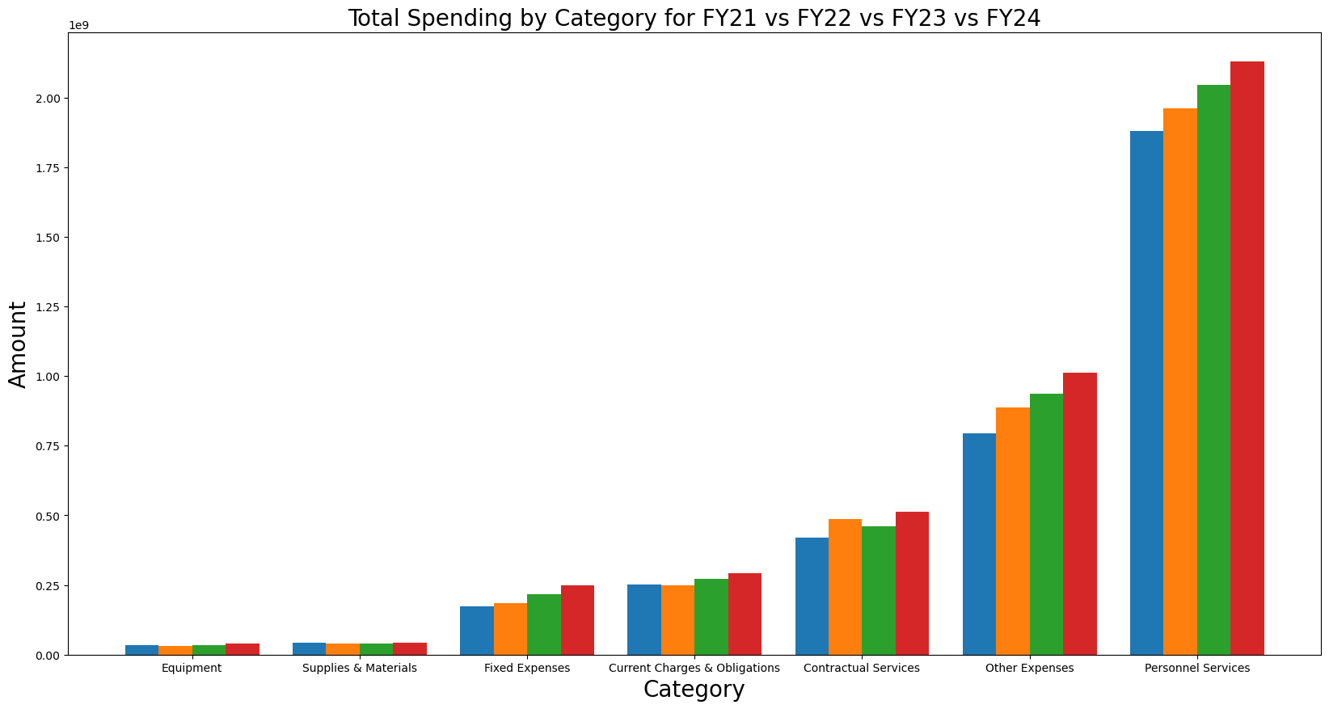

As one might expect, spending by budget category is also trending upwards. Personnel expenses are a significant portion of the budget, which is quite reasonable given that manpower is generally extremely expensive.

Contractual services dipping for ‘23 is a bit strange, but seems to be resuming its upwards trend in ‘24.

Otherwise, not much seems to be out of the ordinary. Spending is relatively in line with projections, with steady growth. Other expenses does make up a large chunk of the city budget, however, and in further analysis we could potentially break down “Other expenses” into more specific categories to better evaluate the spending.

## Spending by area

In examining the expenditure data, it's evident that projected capital expenditures for future years (represented by the red bar) dominate in nearly all areas. Generally, capital grant expenditures are lower than the capital expenditures across the board. Furthermore, the projected expenditures for future years significantly outweigh expenditures for the current years (years 0 and 1). Interestingly, areas like Harbor Islands and East Boston have seen higher expenditures in previous years compared to the current and future years, yet for most other areas, the trend is the opposite, with current and future years of expenditures surpassing prior spendings. This suggests that Boston is likely increasing its investments in most regions, potentially signaling an emphasis on enhancing infrastructure and providing basic amenities for its residents.

On the budgeting front, a majority of the allocated funds for most areas are through prior funding authorizations or grant authorizations. There are a few differences from this pattern. Mattapan stands out with a larger portion of its budget slated for future funding authorizations, hinting a potential developmental trajectory. Meanwhile, Charlestown has a significant proportion of its budget from external funding, as opposed to capital budgets.

Comparing budgets and expenditures, it's clear that future funding makes up the majority of the budget. Noticeably, Dorchester and Roslindale are some individual areas with the highest projected expenditures. Charlestown's predominance in external funding is interesting, and understanding the underlying reasons could offer some insights to the city project.

Overall, the total amount of projected spending (budget) is at least the total amount of the expenditure. However, they are distributed differently. The budget are mostly set in the prior years for all areas, while the spending would occur in the future years instead. This means that the budgeting projects are long term projects, and possibly many of them are going longer than they were initially planned.

## Spending by program

# Contributions

Wanchen Hong: Completed data cleaning and the spending by area sections of EDA and its related questions, including all visualizations and analysis

Alex Zhang: Completed work on spending by category (Visualizations, analysis and questions)

Zhupei Xu: Completed work on spending by department

Phil Ledoit: Completed work on spending by program (visualizations, analysis and questions)